**Assignment A06 - TensorFlow Playground Presentation**

**Team EyeConic**

**Brooke Broderick - W217065417**

**Matthew Choo - W206744145**

**Cameroun White-W216530571**

**Melvis Maduagwu-W216890463**

**Erick Banegas - W216200956**

**NancyChieu-W000098778**

**Yoana Cook - W215913890**

**6252-ITAI-1378-Comp Vision-Artificial Intel-RT-15698 - Spring 2025**

**Professor Anna Devarakonda**

**March 1, 2025**

**Intro**

* In this A06, we will be familiarizing the fundamentals of the neural networks and their behavior. We will be going to a website called playground.tensorflow.org which is an interactive web-based tool to experiment with various neural network configurations and gain insights into how different parameters affect the performance of these networks. First of all, what is a neural network? Well it is a type of method in “artificial intelligence (AI) that teaches computers” that can “process data in a way that is inspired by the human brain”(AWS). It is also a type of machine learning process called deep learning where it can “interconnected nodes or neurons in a layered structure” that resembles a human brain (AWS). In Figure 1, team eyeconic will be playing around the neural network.

**Yoana Cook**

**Task 1 - Activation Functions Results**

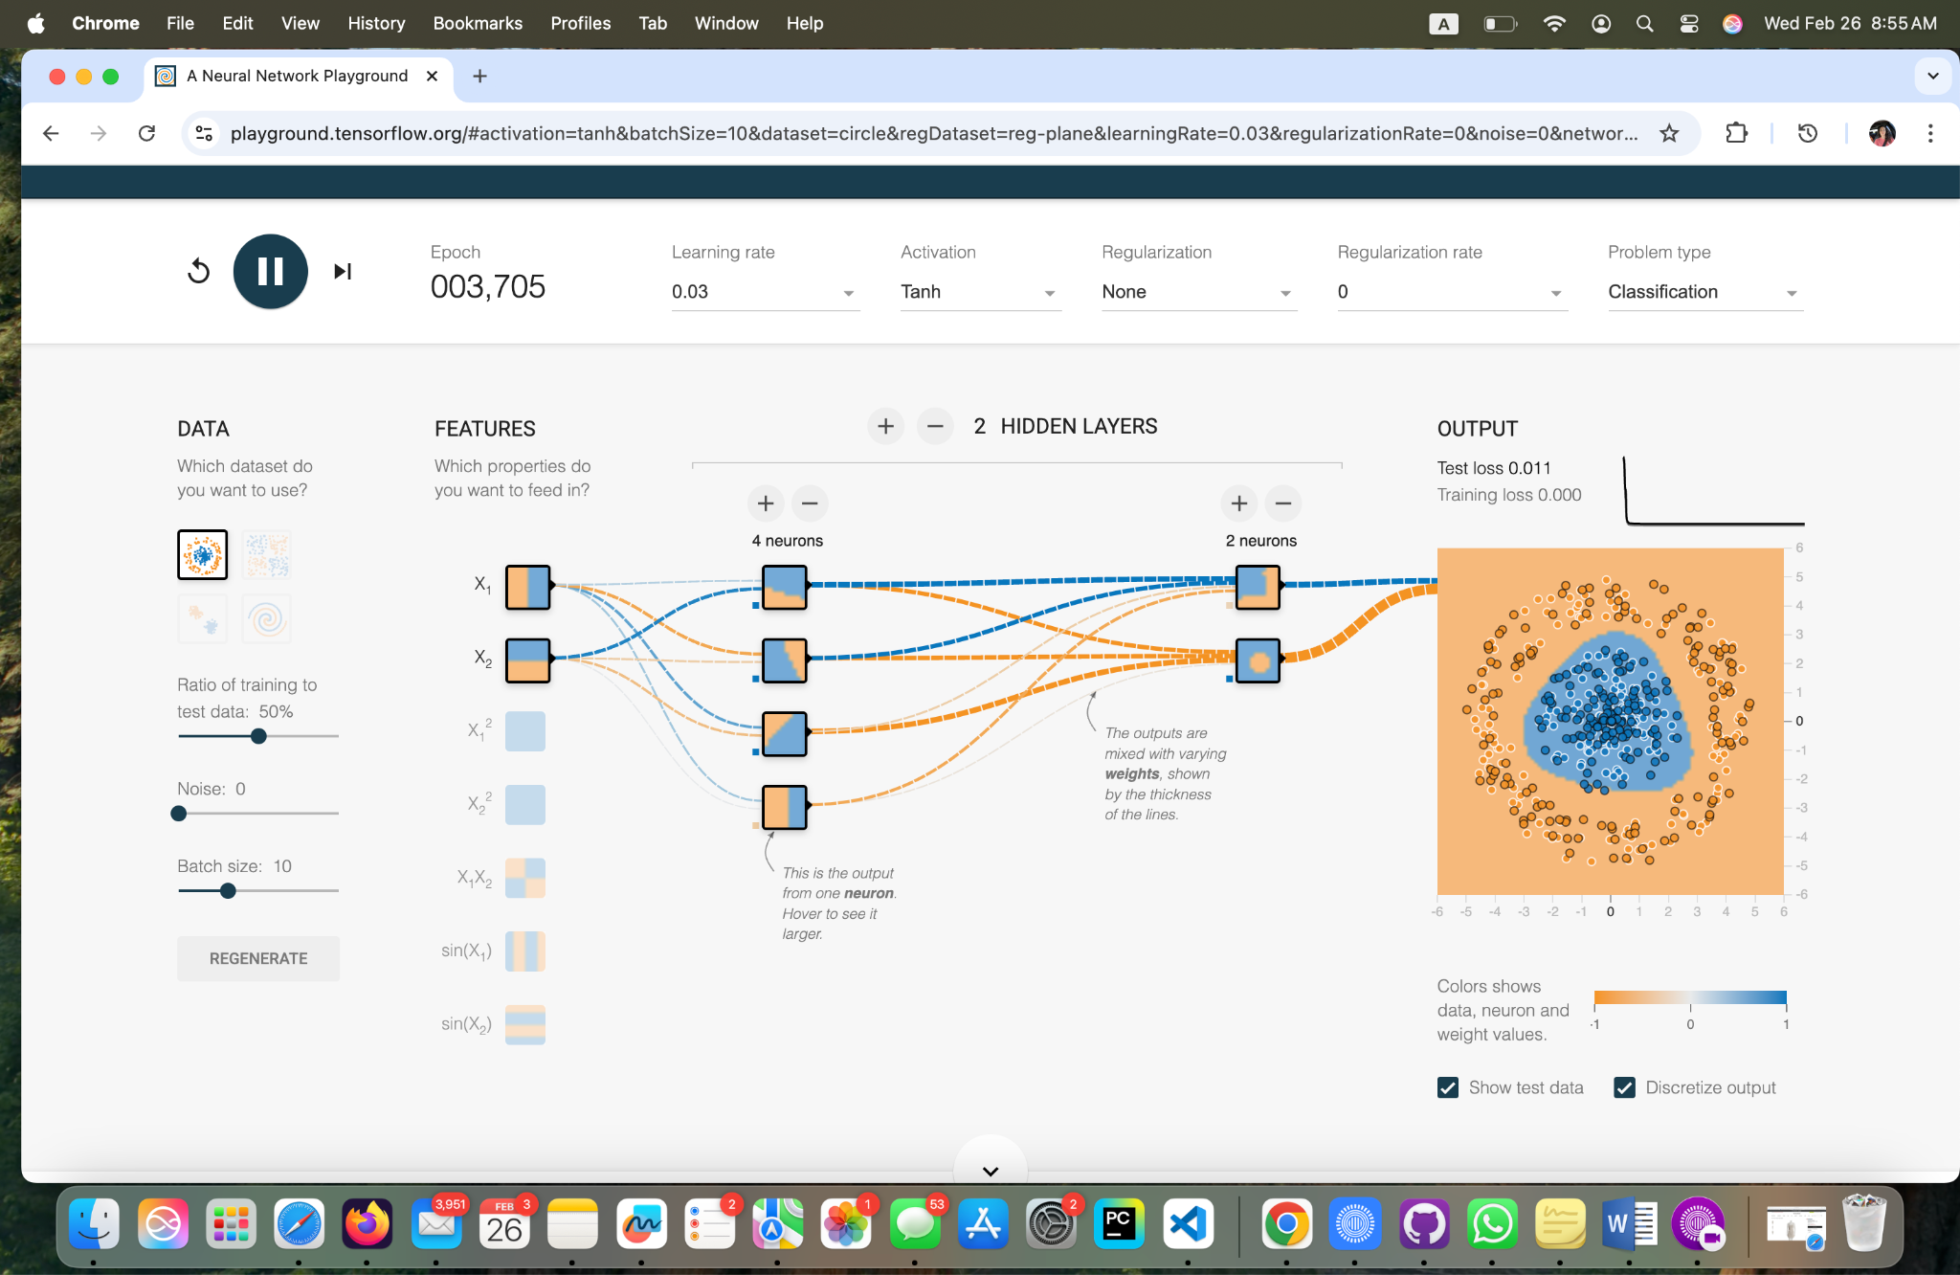

**Task 1 Tahn 0.03 Learning Rate**

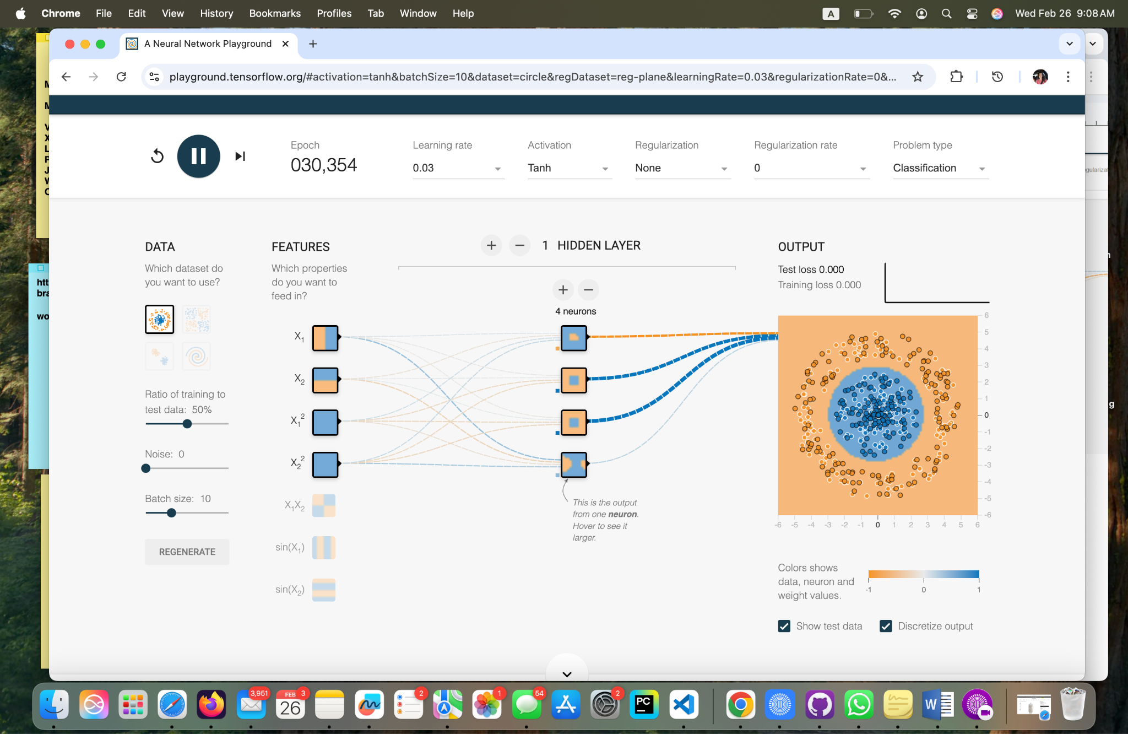

**Task 1, One hidden layer with Four Neurons, Activation - Tahn.**

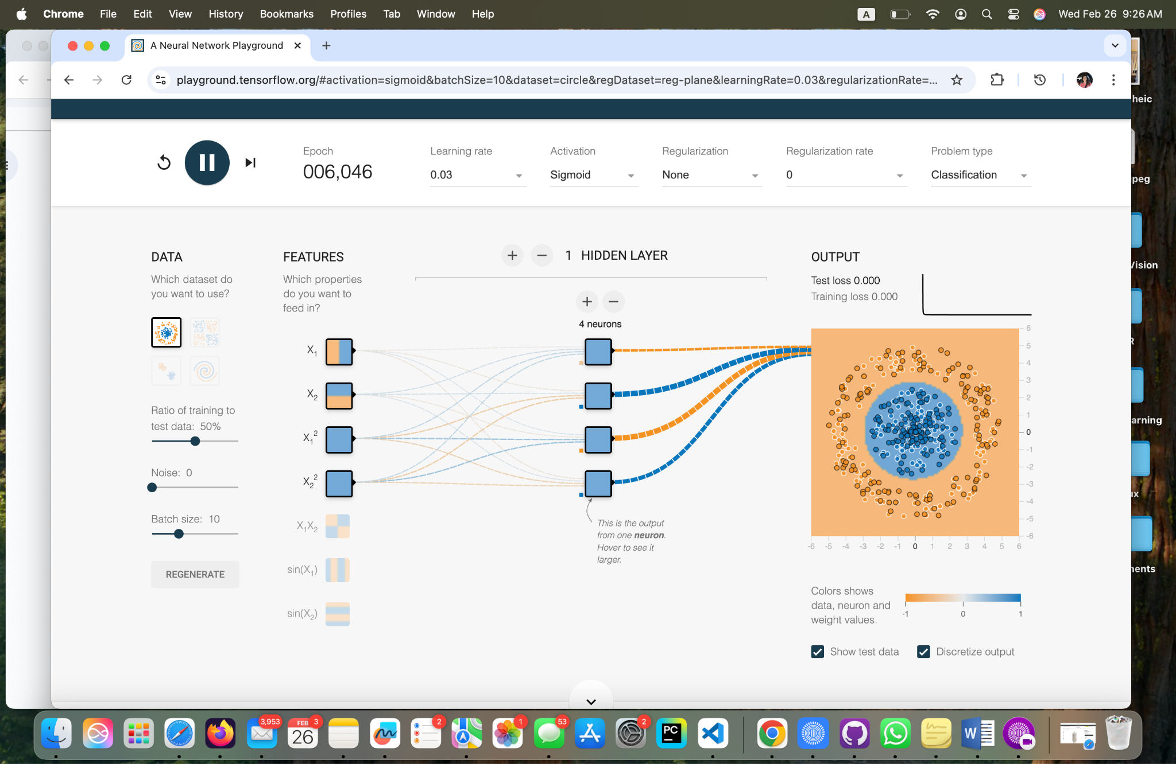

**Task 1, One hidden layer with Four Neurons, Activation - Sigmoid.**

**Task 2 - Hidden Layer Neurons Results**

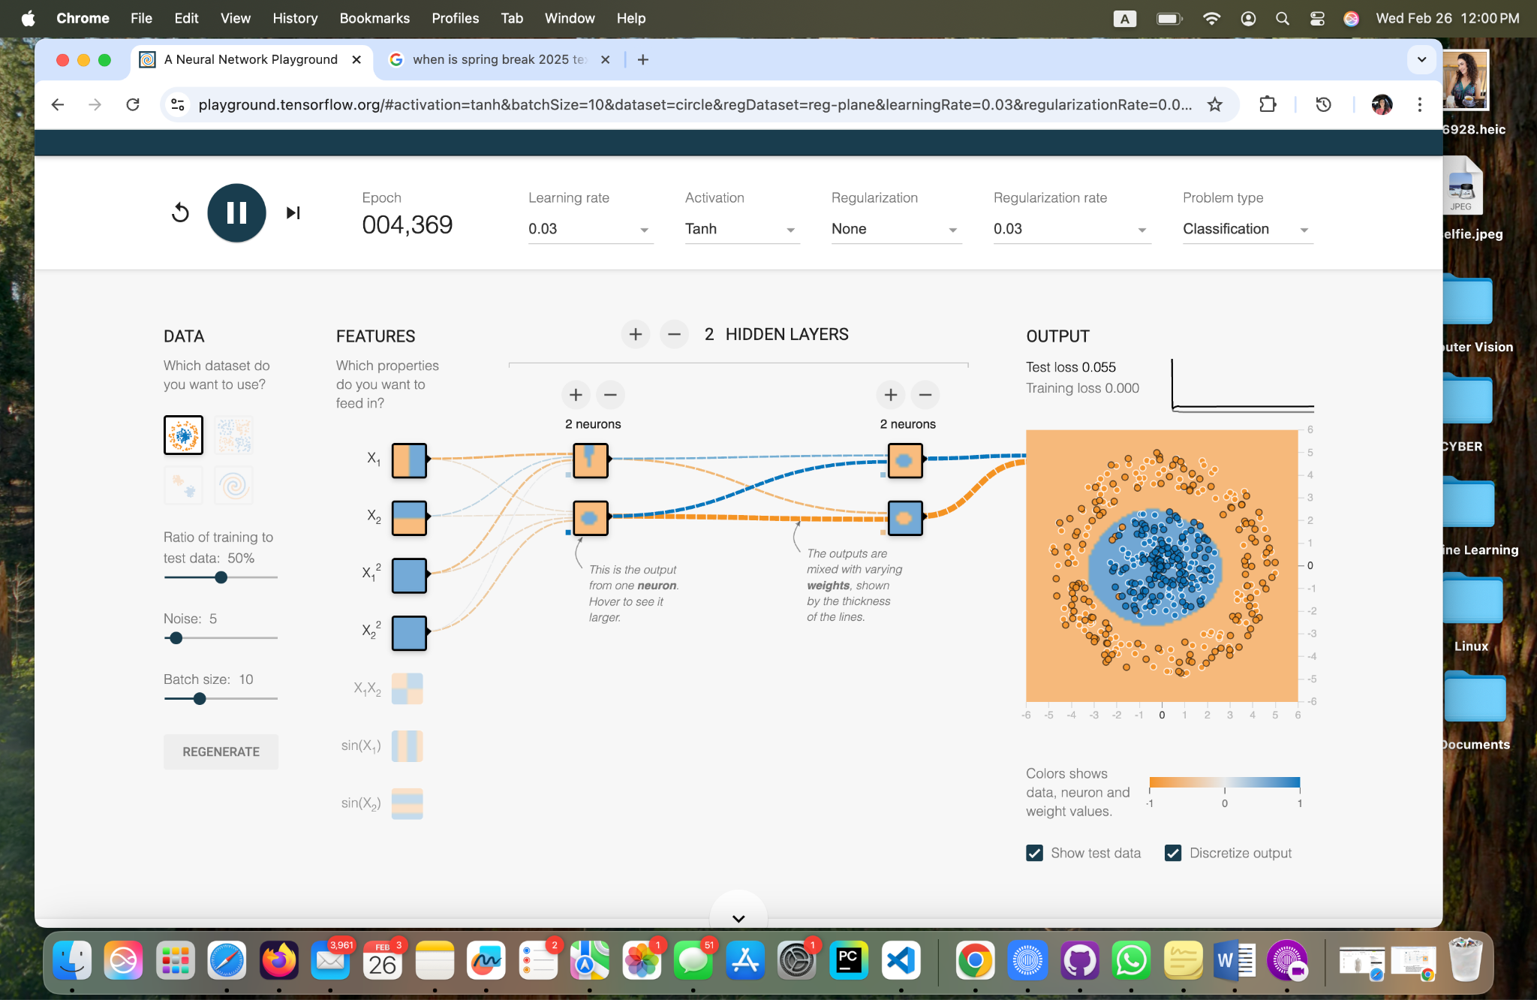

**Task 2: Two Hidden Layers, with Two Neurons Each, Activation - Tahn, Learning Rate - 0.03**

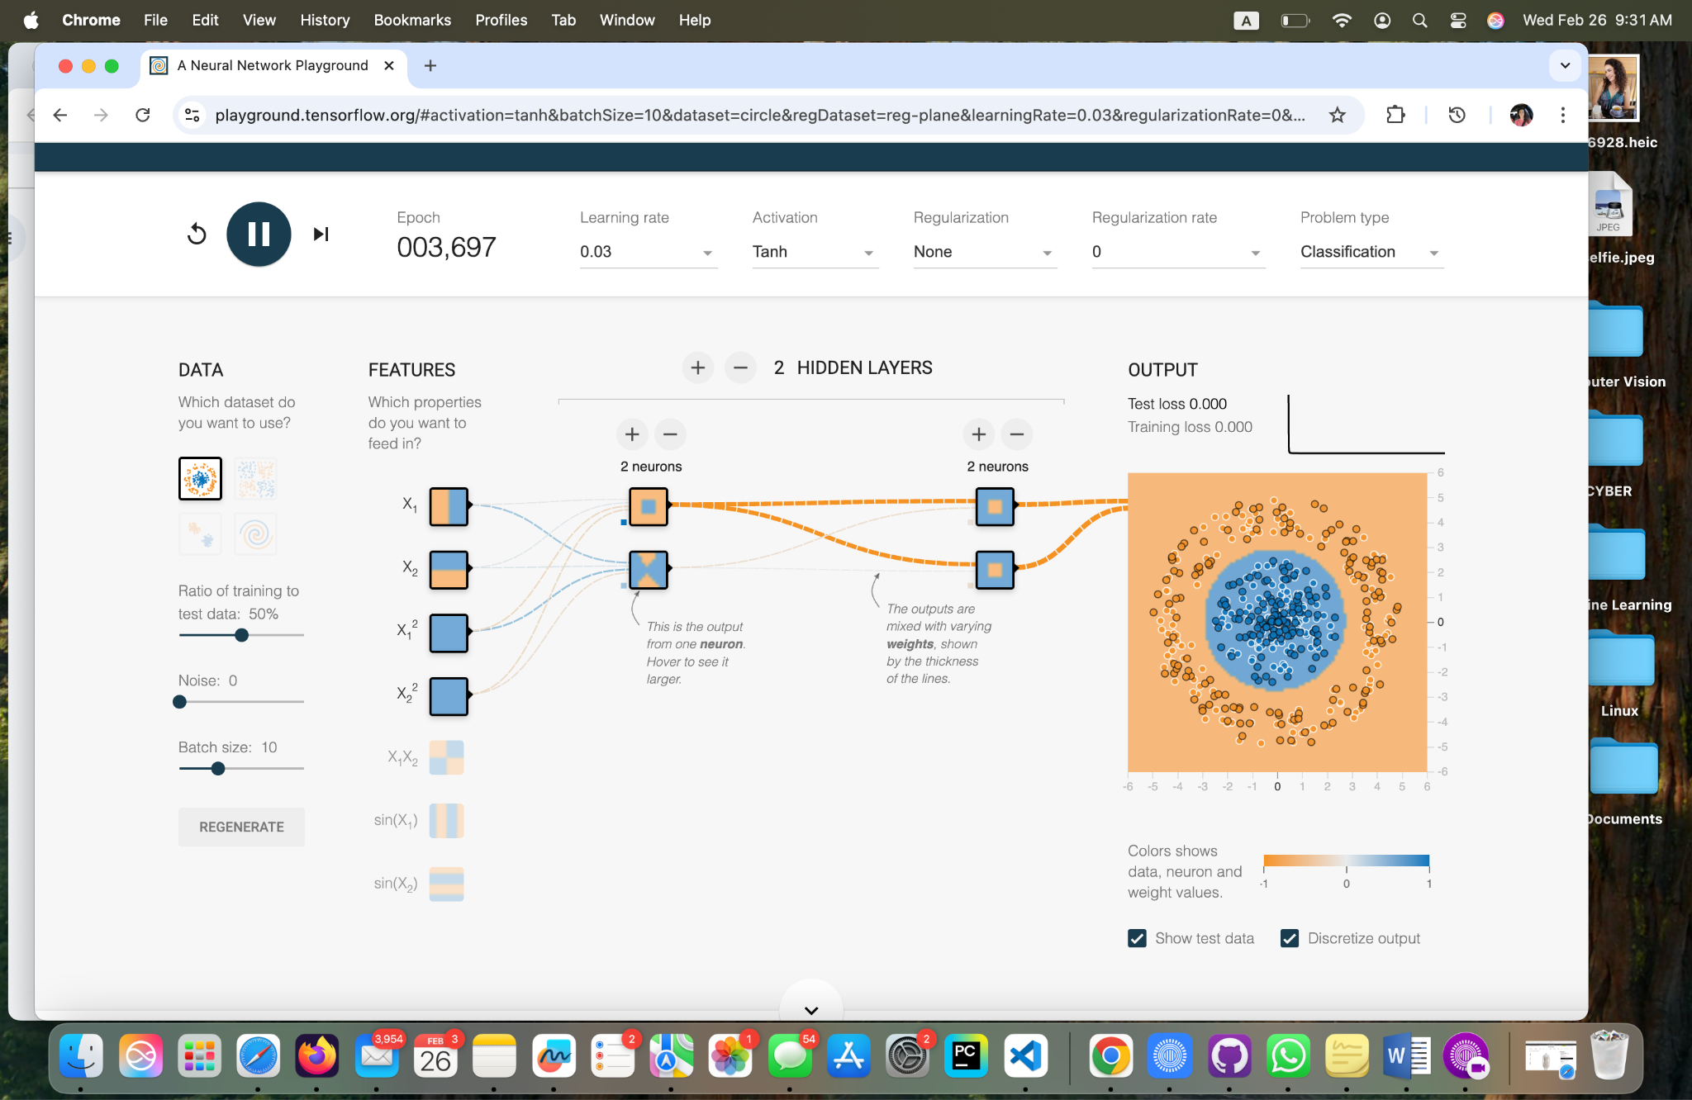

**Task 2: Two Hidden Layers, with Two Neurons Each, Activation - Tahn, Learning Rate - 0.03**

**Task 3 - Learning Rate Results**

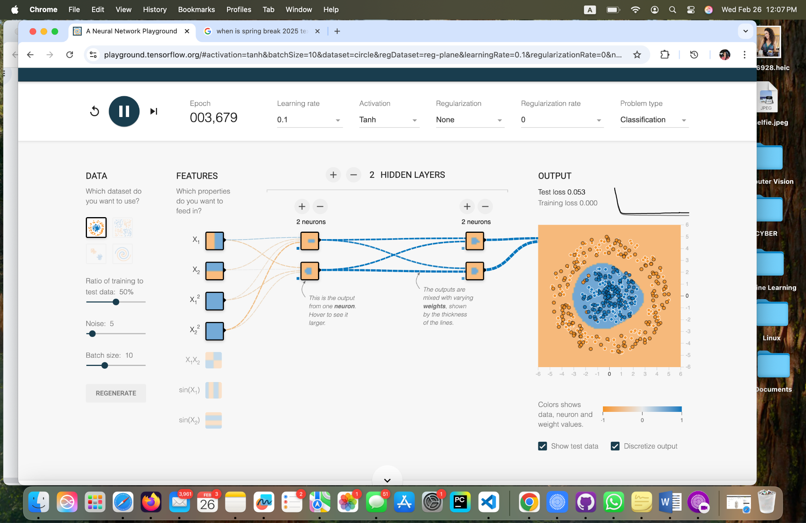

**Task 3 - Two Hidden Layers, with Two Neurons Each, Noise 5, Learning Rate 0.1, Activation - Tahn.**

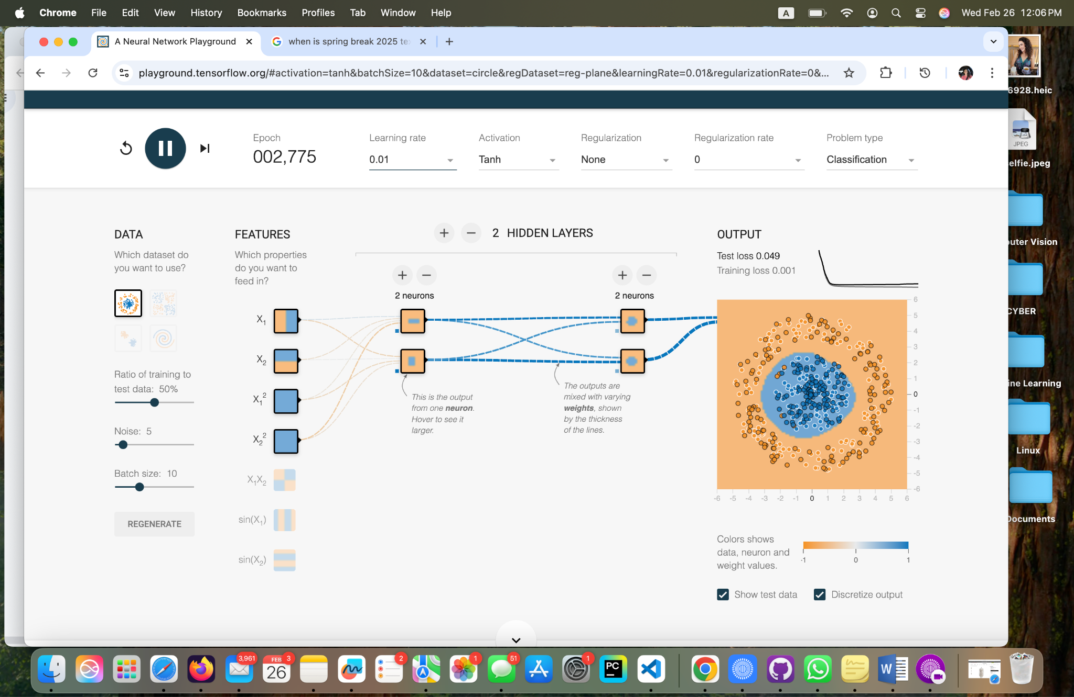

**Task 3 - Two Hidden Layers, with Two Neurons Each, Noise 5, Learning Rate 0.01, Activation - Tahn.**

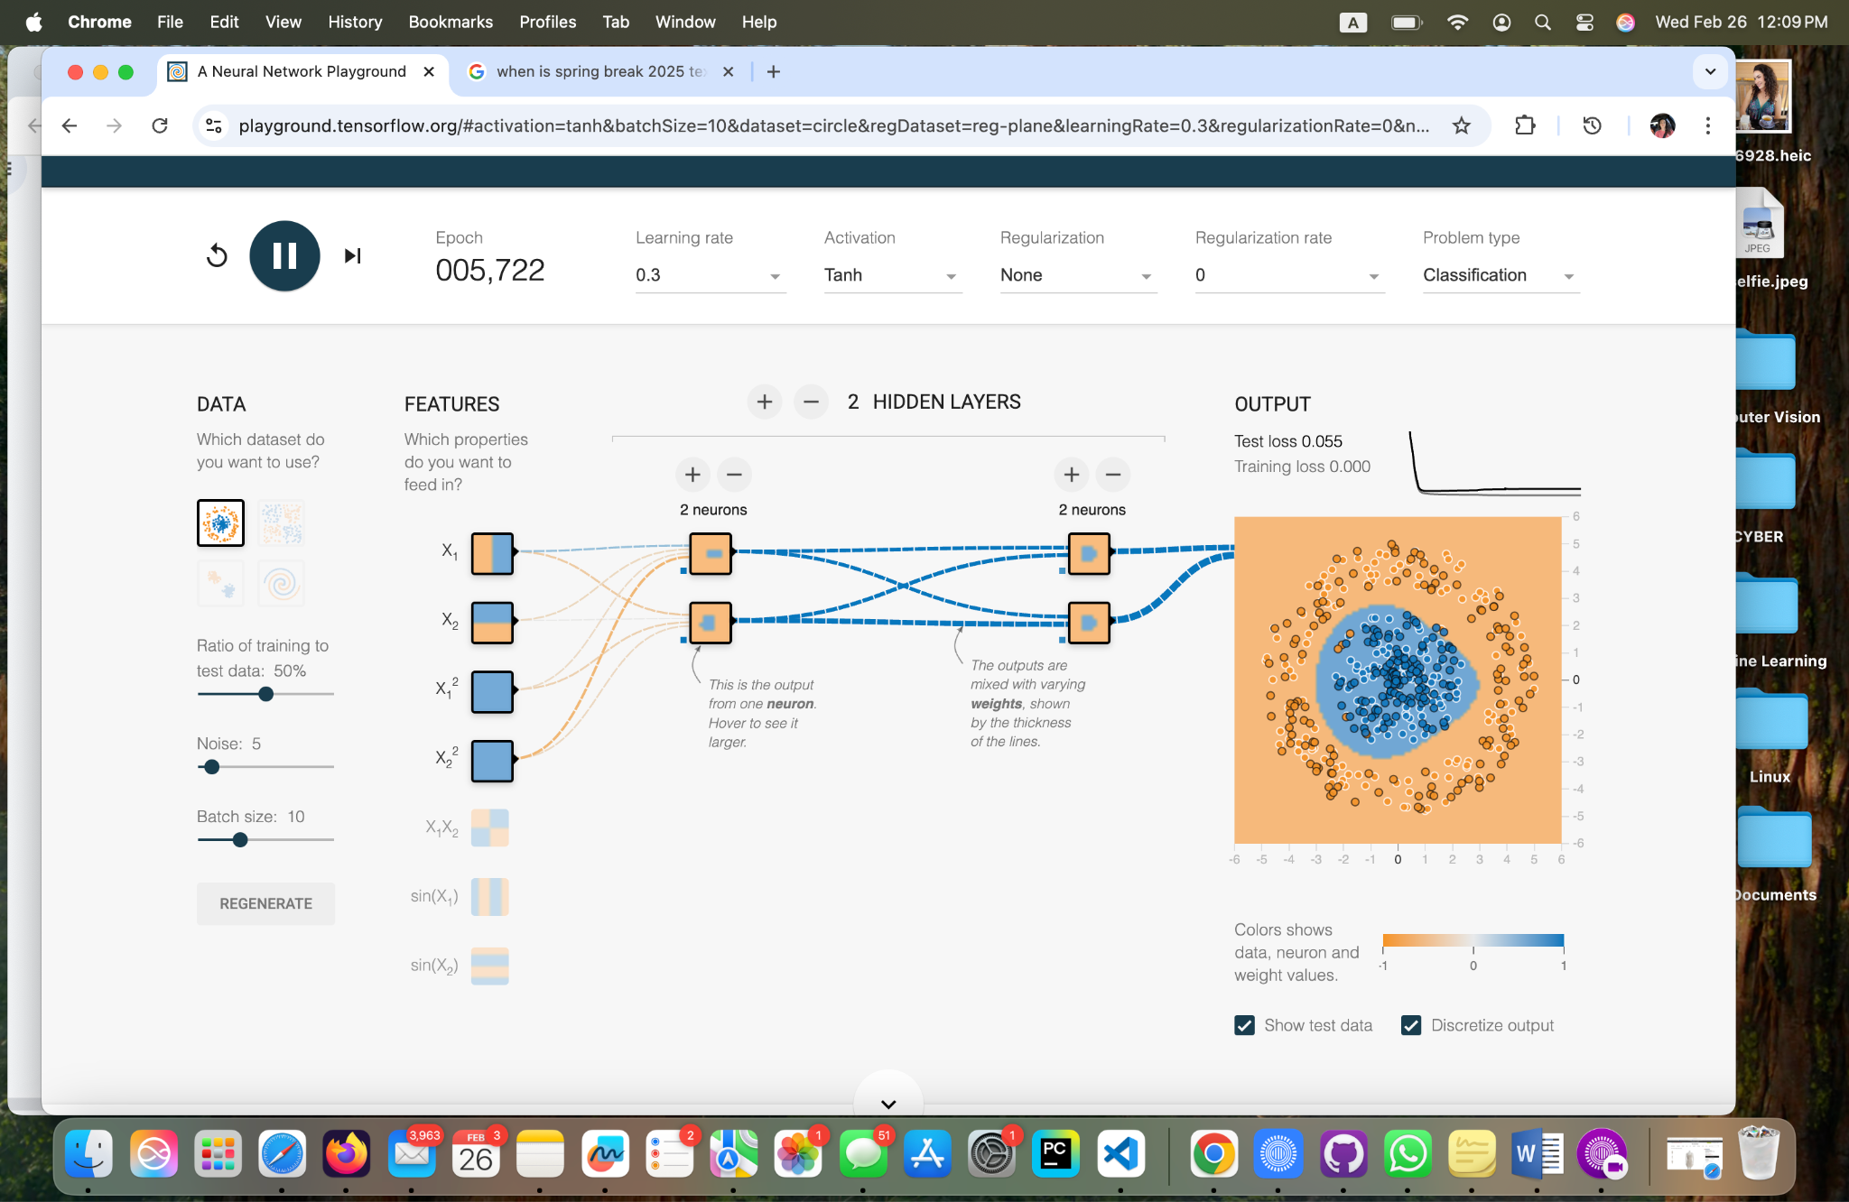

**Task 3 - Two Hidden Layers, with Two Neurons Each, Noise 5, Learning Rate 0.3, Activation - Tahn.**

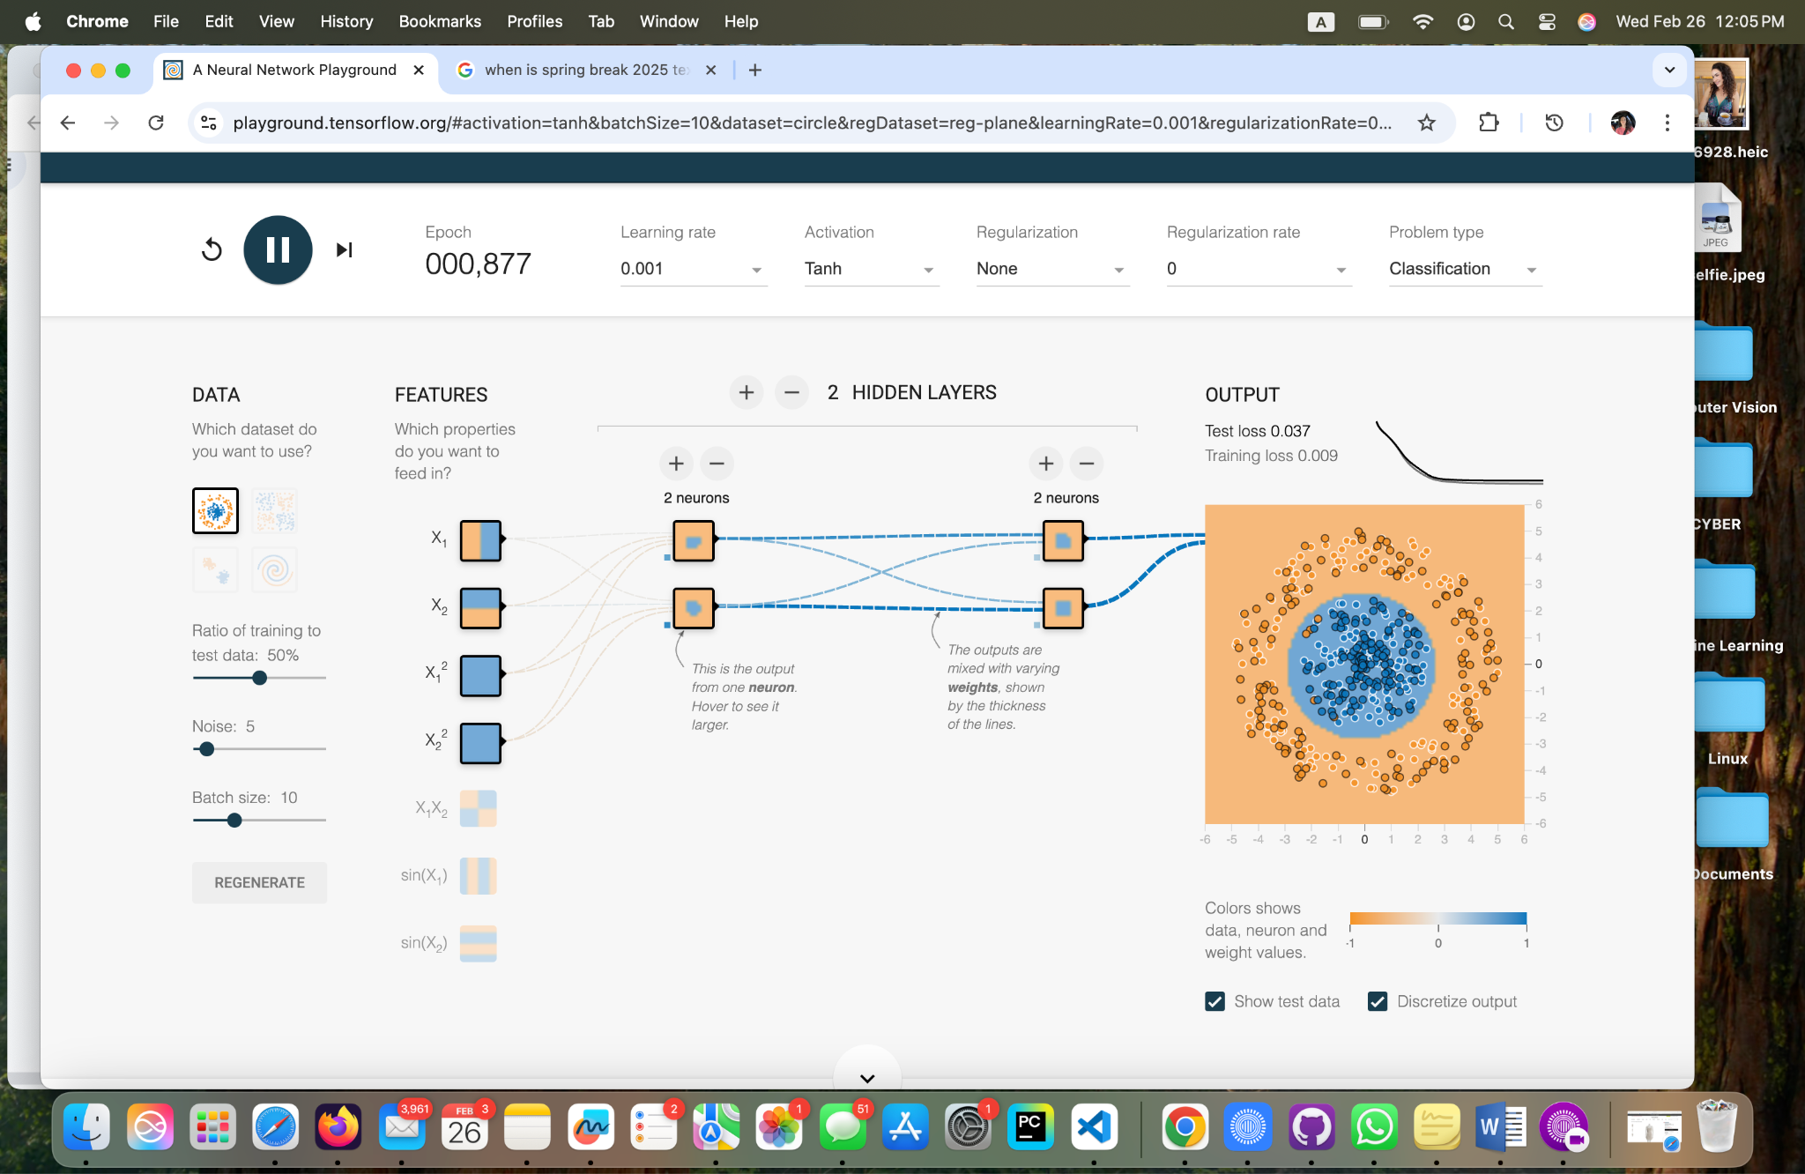

**Task 3 - Two Hidden Layers, with Two Neurons Each, Noise 5, Learning Rate 0.001, Activation - Tahn.**

**Task 4 - Data Noise Results**

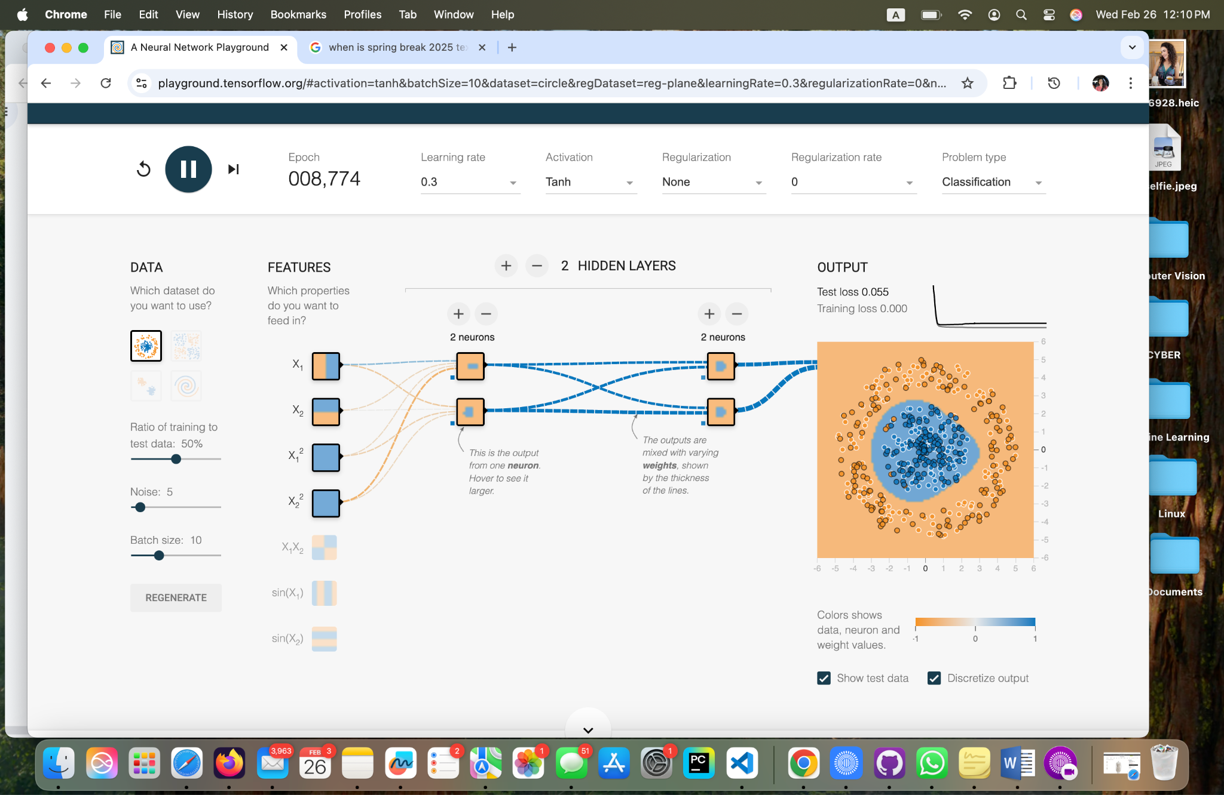

**M**

**Task 4 - Two Hidden Layers, with Two Neurons Each, Noise 5, Learning Rate 0.3, Activation - Tahn.**

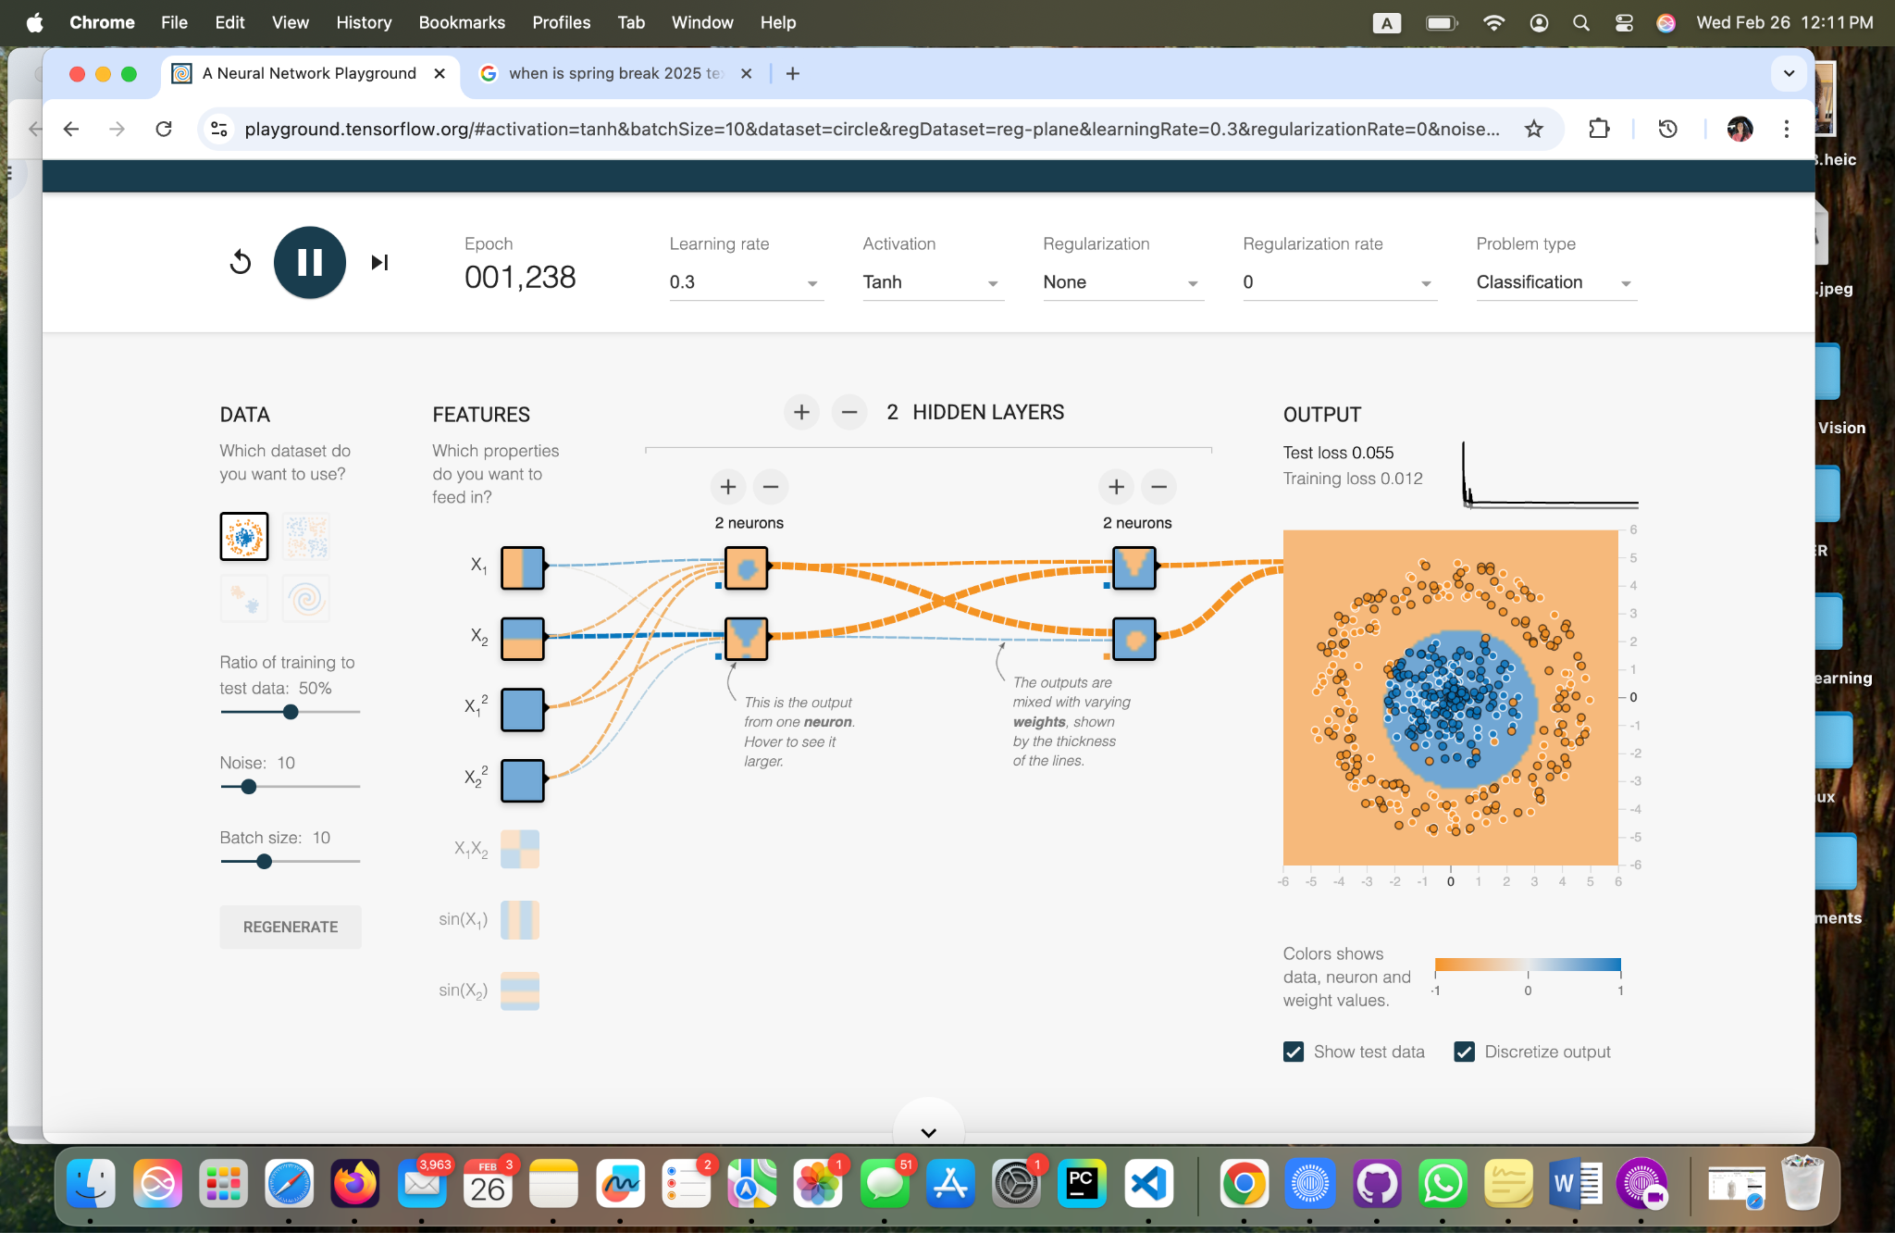

**Task 4 - Two Hidden Layers, with Two Neurons Each, Noise 10, Learning Rate 0.3, Activation - Tahn.**

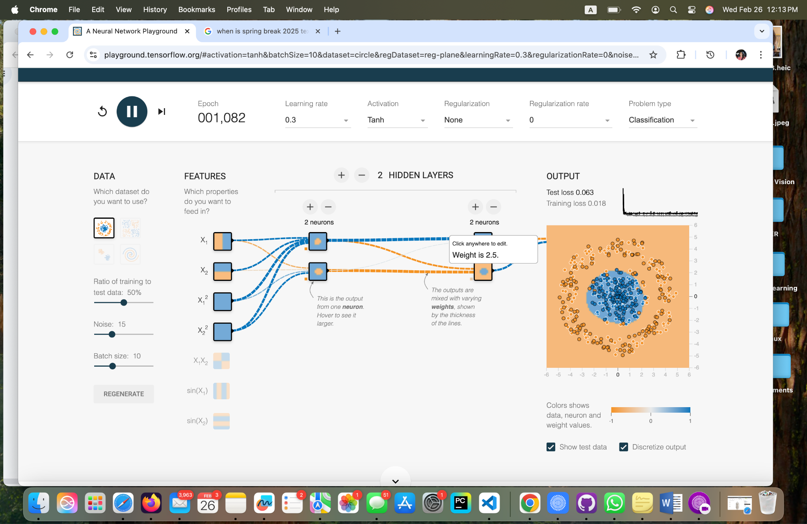

**Task 4 - Two Hidden Layers, with Two Neurons Each, Noise 15, Learning Rate 0.3, Activation - Tahn.**

**Task 5 - Dataset Exploration Results**

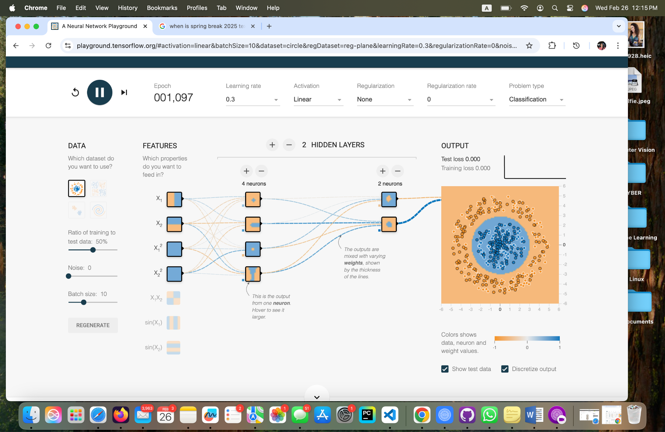

**Task 5 - Two Hidden Layers, One with Four Neurons and One with Two Neurons, Learning Rate 0.3, Activation - Linear.**

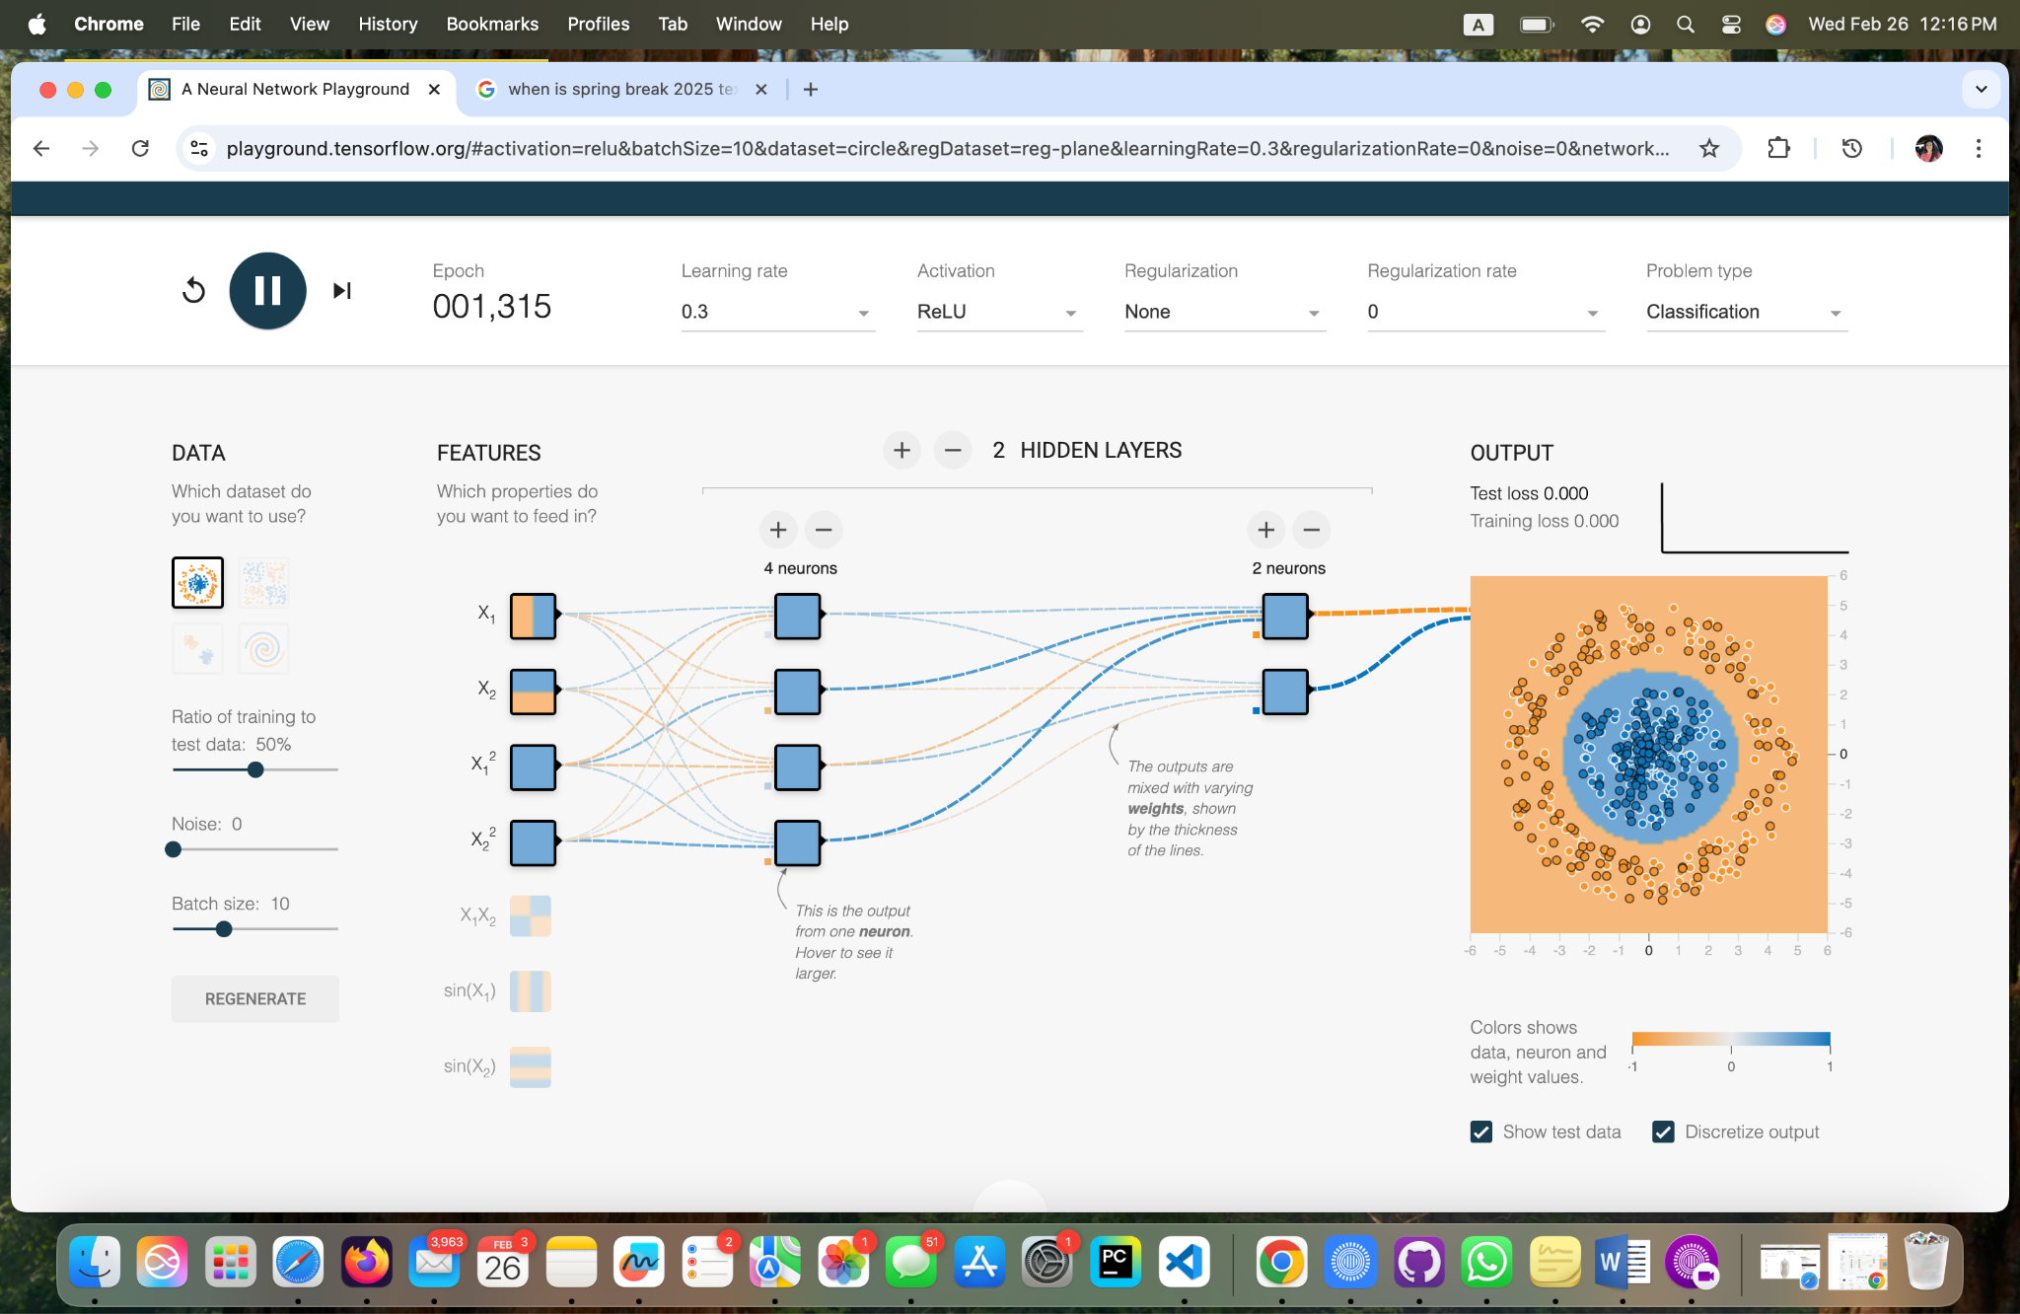

**Task 5 - Two Hidden Layers, One with Four Neurons and One with Two Neurons, Learning Rate 0.3, Activation - ReLu.**

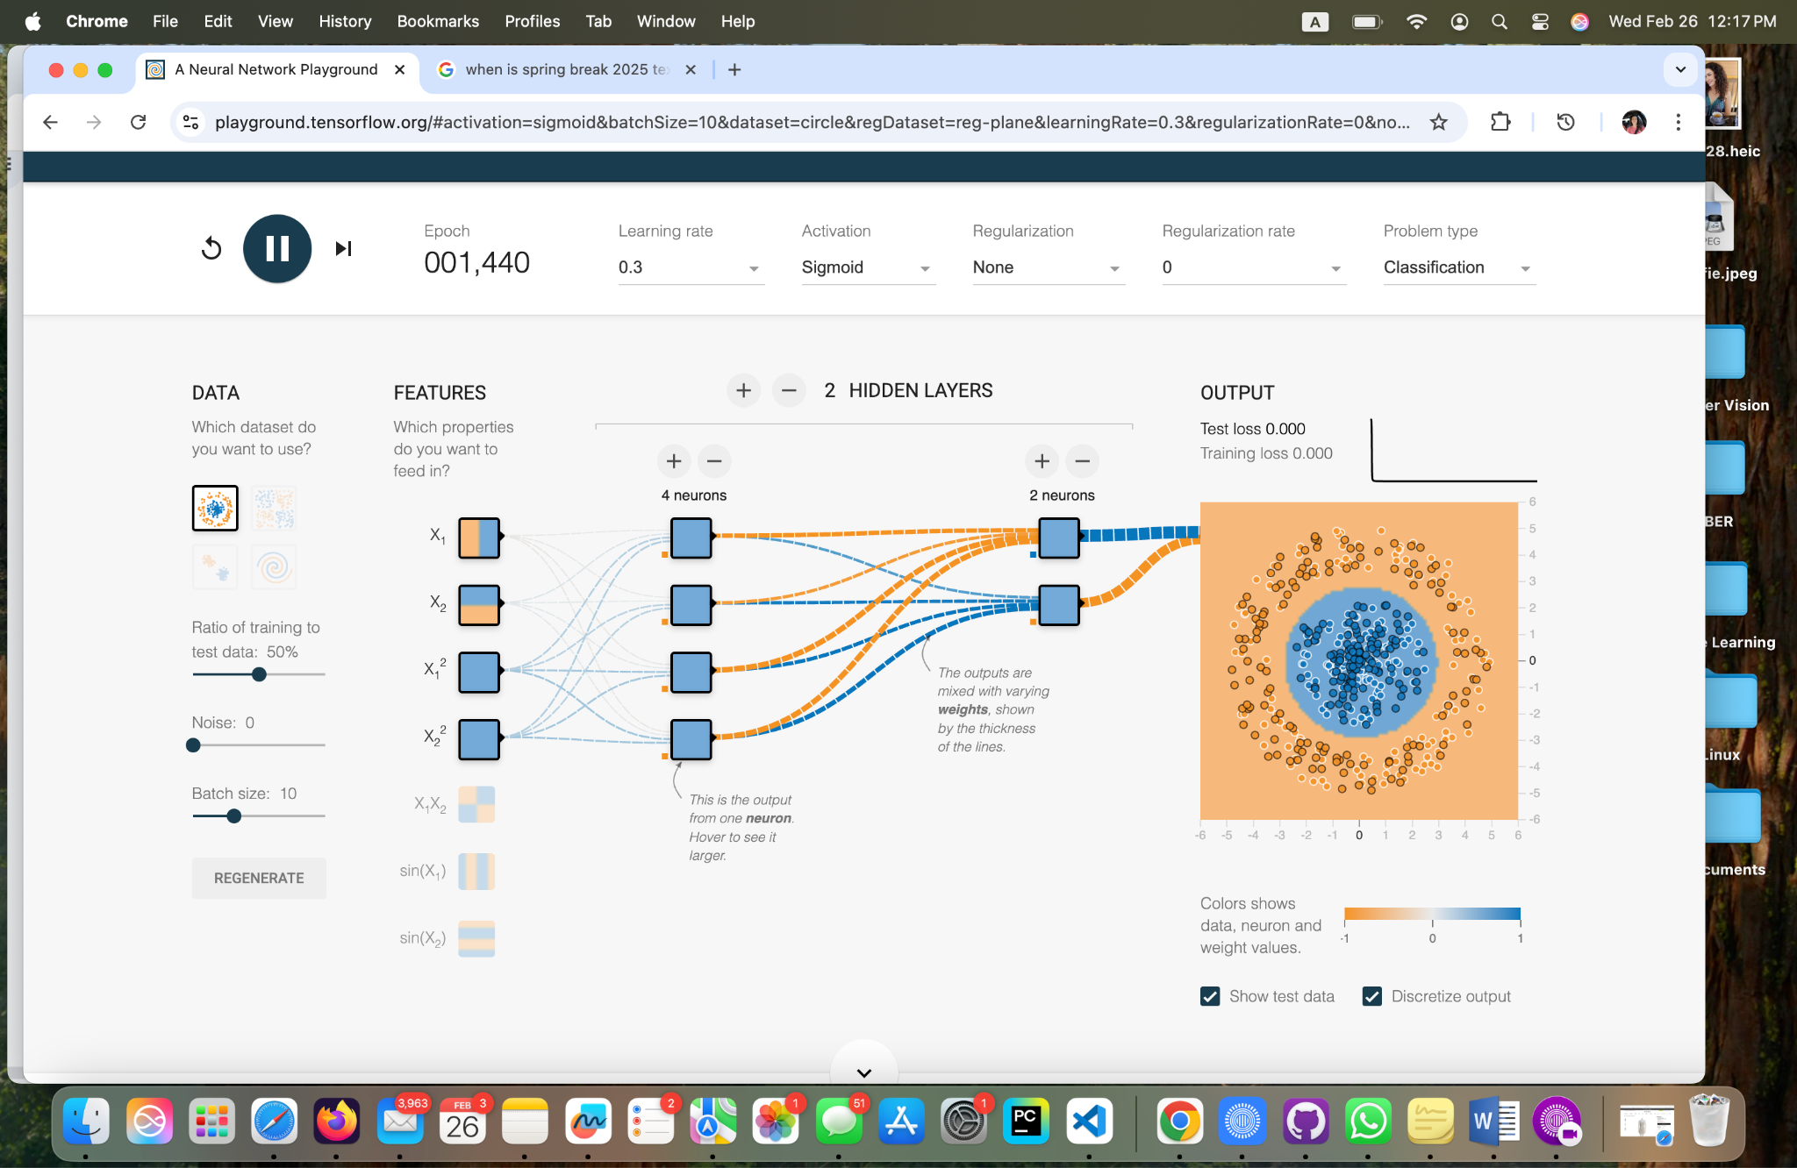

**Task 5 - Two Hidden Layers, One with Four Neurons and One with Two Neurons, Learning Rate 0.3, Activation - Sigmoid.**

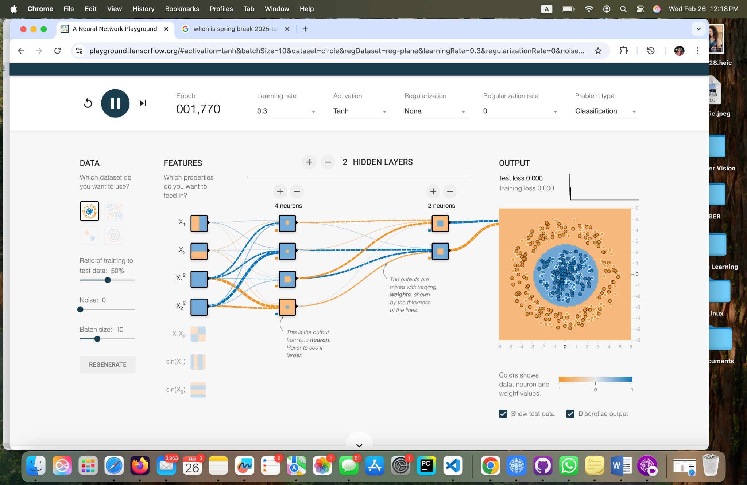

**Task 5 - Two Hidden Layers, One with Four Neurons and One with Two Neurons, Learning Rate 0.3, Activation - Tahn.**

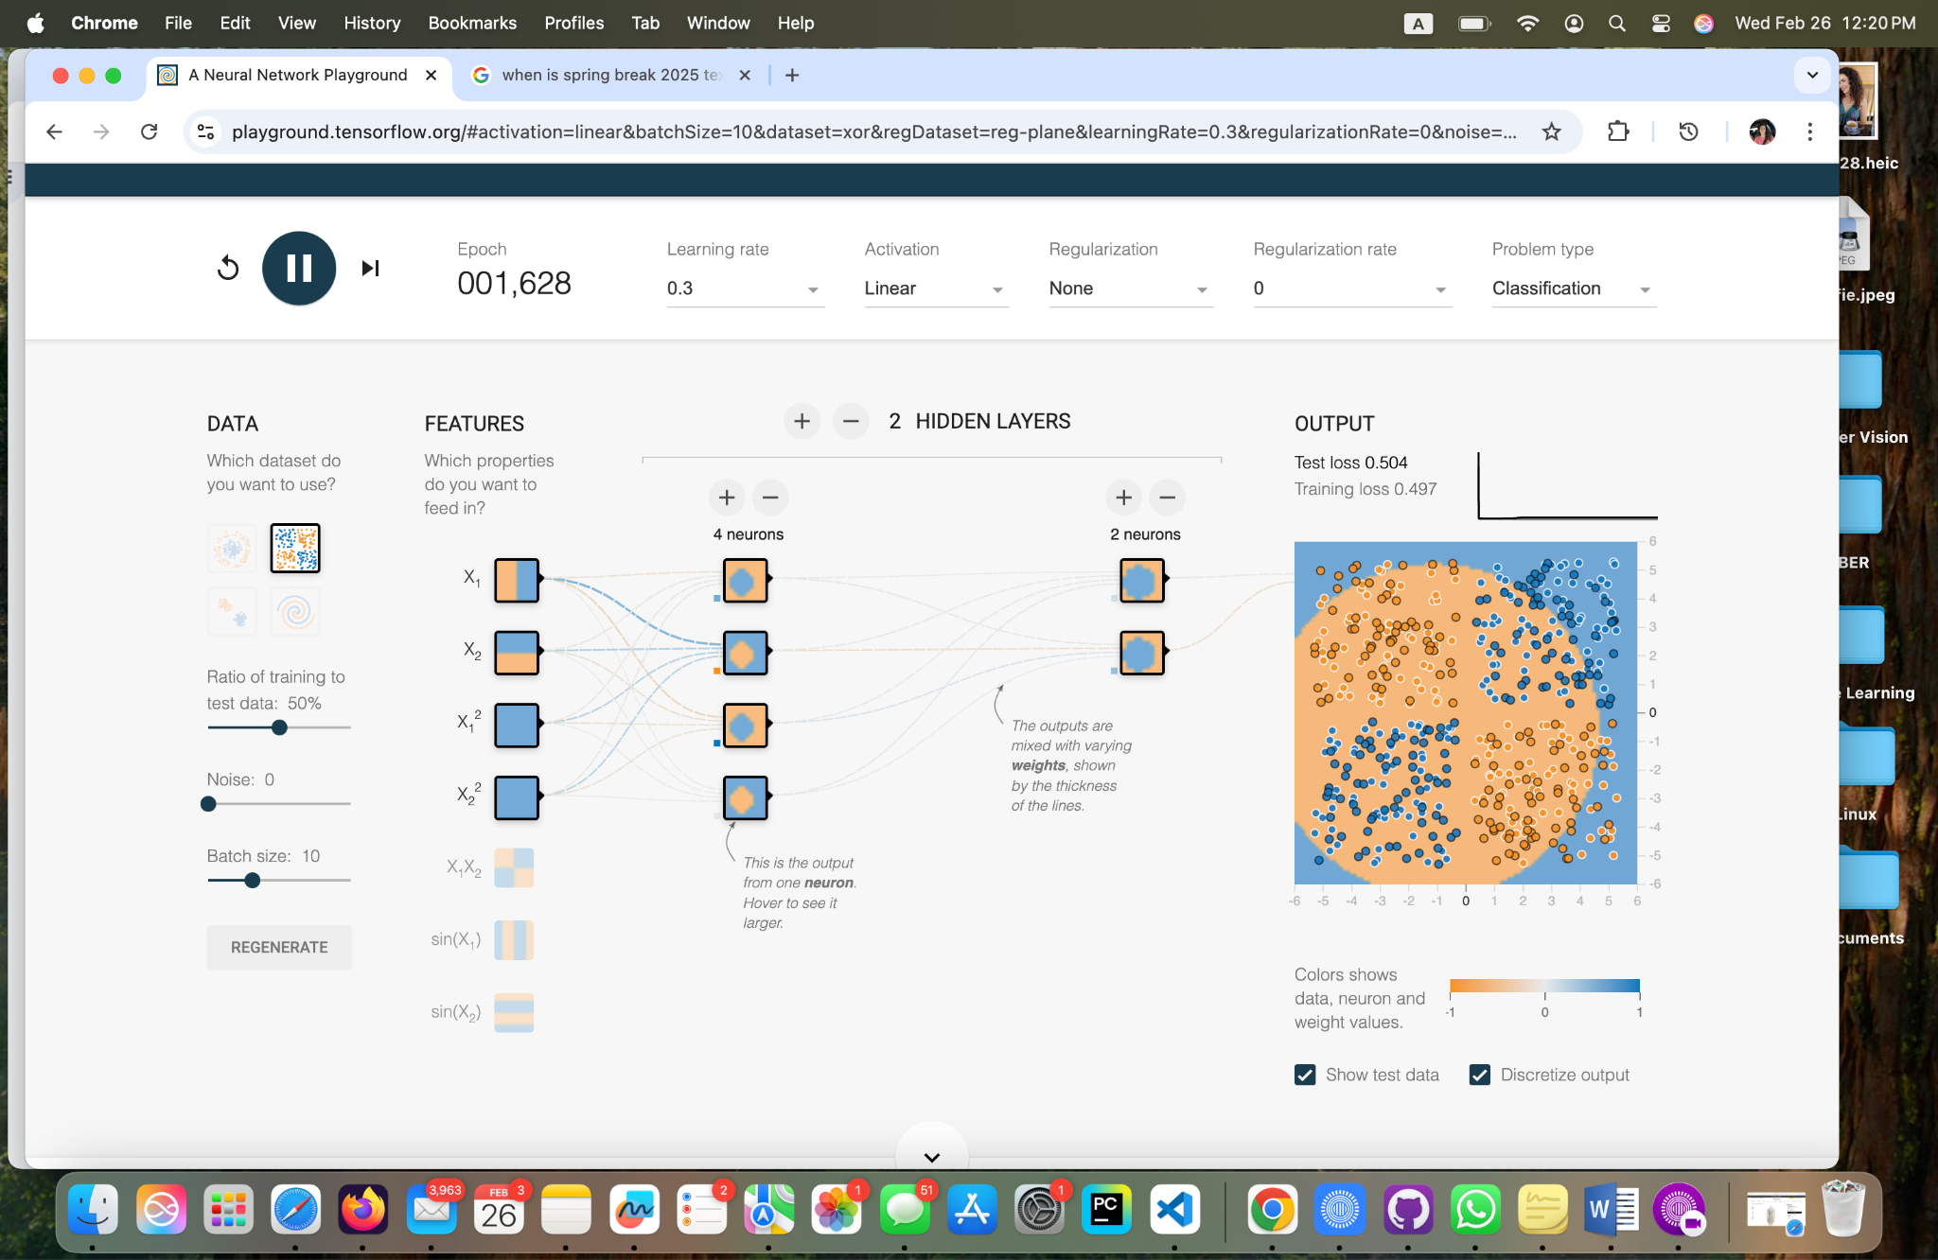

**Different datasets**

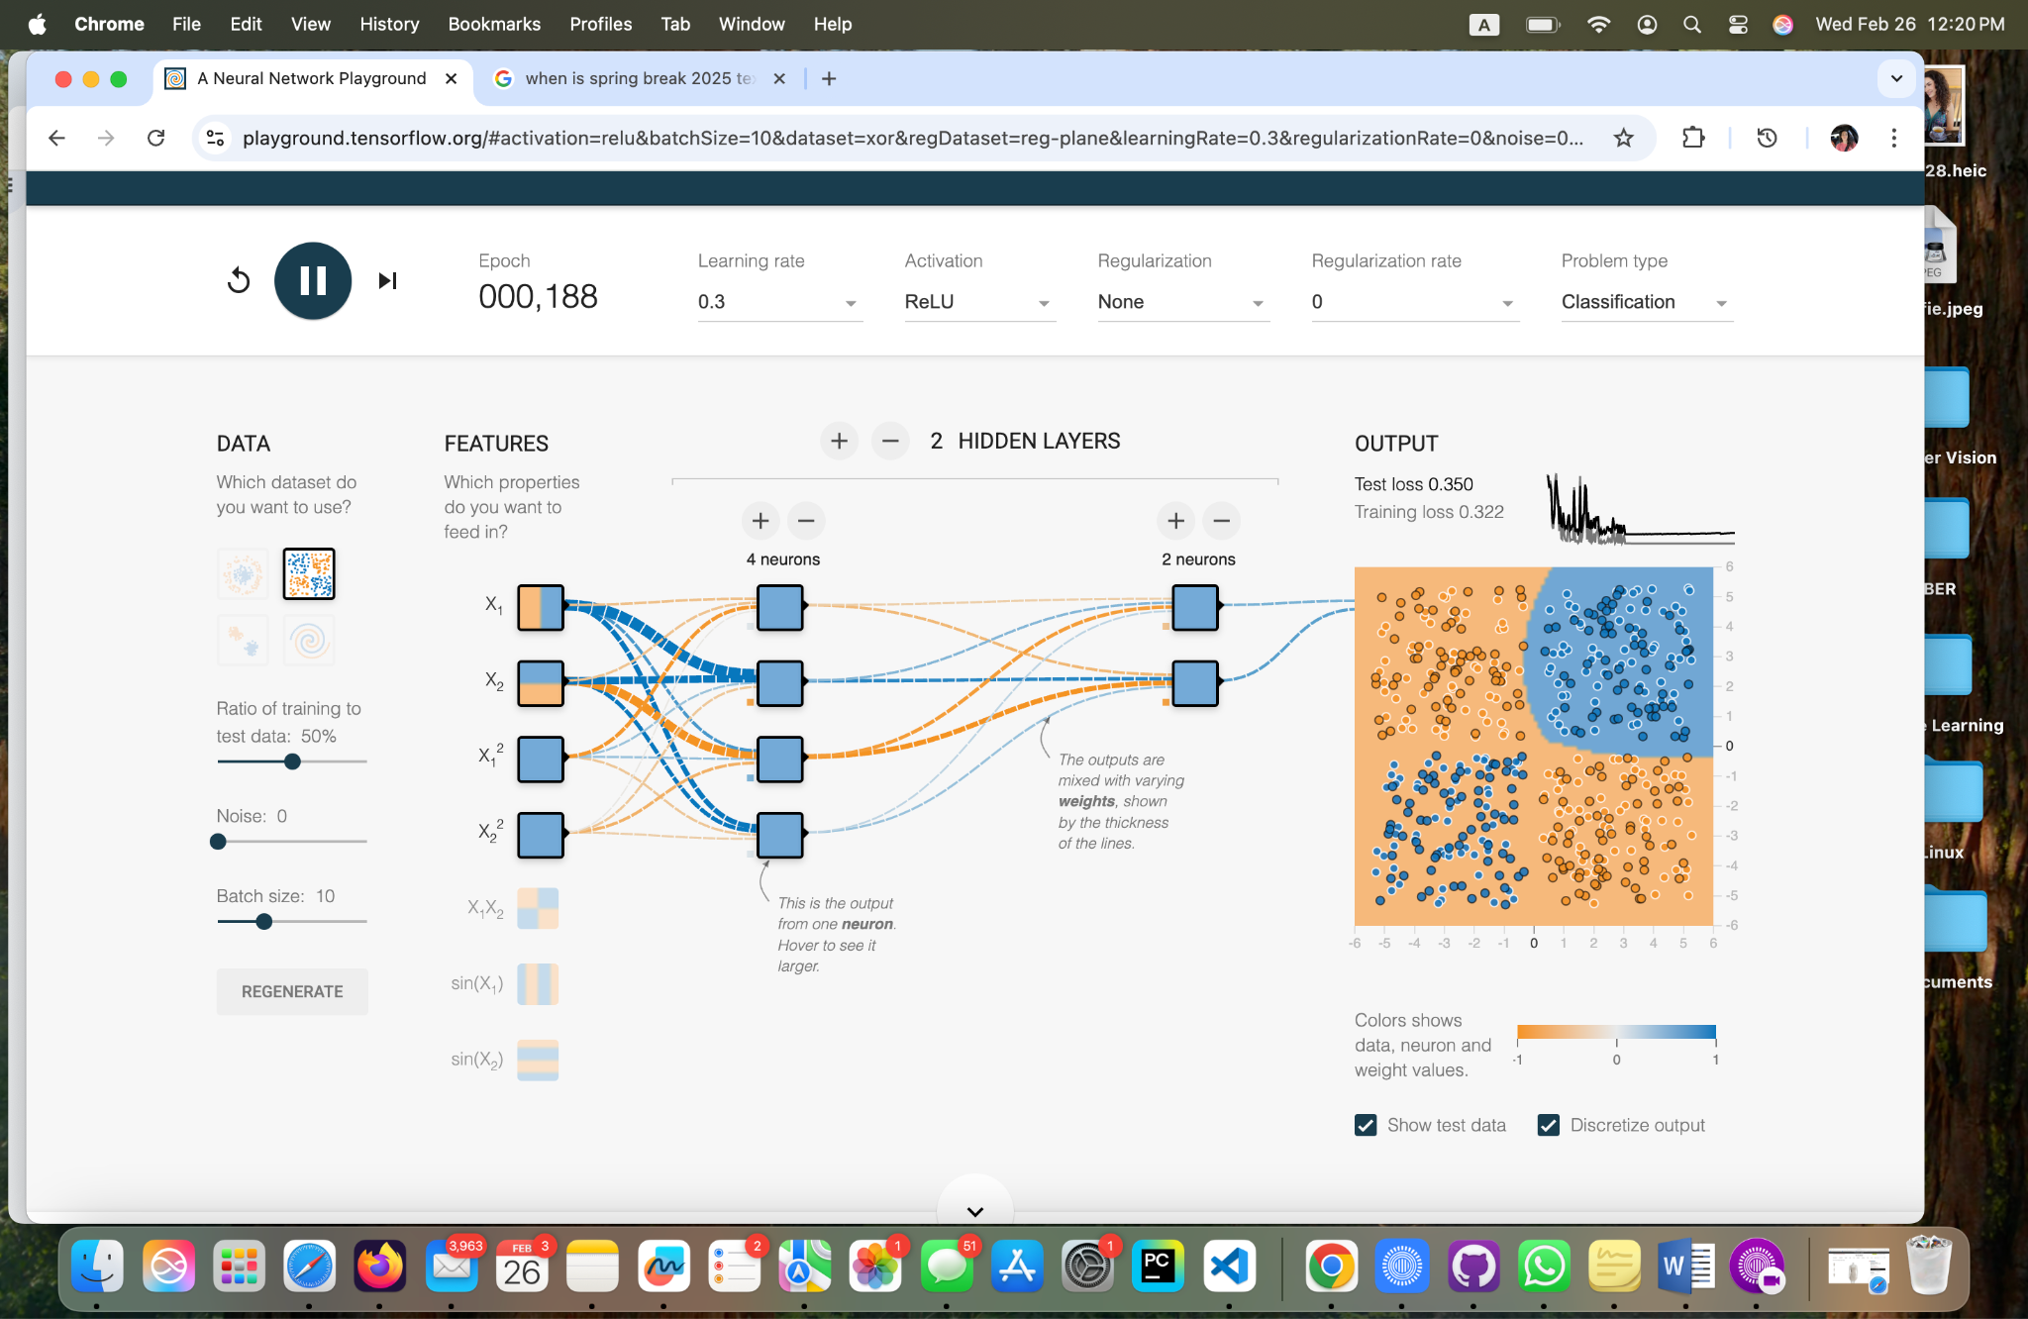

**Different datasets**

**Conclusions:**

**Brooke Broderick**

**Matthew Choo**

* **After working on Task 1 - 5, I found it interesting and unexpected because of the results being given. Can change different types of datasets, learning rate, regularization, regularization rate, problem, ratio of training test data, noise, batch size, and activation to produce results. Was surprised that you can add different properties and put hidden layers and neurons to produce amazing results. Overall, this playground tensorflow is an interesting game.**

**Cameroun White**

**Engaging with Task 1-5, I’ve come to the conclusion that changing your datasets, activation functions, data noise, learning rate, and the many other options can make some pretty interesting outputs. Every factor for the most plays a part in the end. This assignment was indeed a playground because you can spend a lot of time rendering different end goals and come up with many solutions.**

**Melvis Maduagwu**

* **This tensorflow playground was a good representation of how neural networks come to life. It shows how the different components like Learning rate, activation functions, noise, regularization and others are put together to produce an output. I learned that the neurons in a neural network are the fundamental processing units of a neural network, inspired by biological neurons in the brain. These Neurons are divided into three layers which are; The input layer, the hidden layer and the output layer. Each neuron takes inputs, processes them, and passes an output to the next layer. I must say, I may need to do some more practice with neural networks.**

**Erick Banegas**

* **What I learned from these tests is that it’s not just about adding more layers to a neural network but finding a balance between the number of neurons, the activation function, and the amount of training data. I saw that having more neurons per layer is more effective than just adding more layers, that Tanh and Sigmoid work better than Linear, and that too much noise in the data affects learning. I also noticed that if the model doesn’t have enough training data, it doesn’t generalize well. In the end, the key is to fine-tune these parameters instead of just making the network bigger or more complex without a clear strategy.**

**NancyChieu**

* **Working with Task 1-5, I got more familiar with TensorFlow as a tool in machine learning for computer vision. In Task 1 I learned that Sigmoid is the most powerful one among the four activation functions. In Task 2 the number of neurons and hidden layers affect the outputs in different ways. In Task 3 I learned the relationship of learning rate with convergence speed and accuracy. Then I changed the noise and datasets to observe what happened to machine learning. TensorFlow is an important and fun tool to explore neural networks in machine learning.**

**Yoana Cook**

* This assignment was about getting familiar with neural networks, and more specifically, how computers learn patterns and make decisions. I am interpreting it like teaching a robot to recognize shapes or patterns. In order to do that, we were using the tool called *TensorFlow Playground,* which lets one play around with neural networks in a visual way. There was no coding required, just tweaking settings and seeing what happens.
* Neural networks mimic the functioning of a human brain and are made up of layers or "neurons" (like tiny decision-makers) that work together to solve problems. The key components are *input layers* (where data comes in), *hidden layers* (where the magic happens), and *output layers* (where the final decision is made). I also looked up some references (like class slides and verified info from tools like GPT) to make sure I understood the basics.

* In Task 1, I played with activation functions. These are like the rules that decide how a neuron should react to the data it gets. I tried three main ones:
* ReLU: It only lets positive values pass through and blocks negatives. It made the network learn very fast. Sigmoid: This one squishes values into a range between 0 and 1. It worked okay, but the network seems slower to learn. Tanh: Similar to sigmoid but squishes values between -1 and 1. It was a bit better than sigmoid but still not as fast as ReLU. In task one I have learned that activation functions are very important because they decide how the network processes information. ReLU is great for speed, but sometimes simpler is not always better - it depends on the problem!
* In Task 2, I messed around with the number of neurons in the hidden layer and even added more hidden layers. Here’s what happened: With fewer neurons, the network struggled to learn complex patterns. It was like trying to solve a puzzle with missing pieces. With more neurons, the network got better at learning, but only up to a point. Too many neurons made it slow and sometimes it even over complicated things (a problem called overfitting). Adding more hidden layers helped the network learn even more complex patterns, but again, too many layers made it slow and inefficient. I have learned that neurons and hidden layers are like the brainpower of the network. You need enough to solve the problem, but too much can backfire.
* In Task 3, I adjusted the learning rate, which controls how fast the network learns. Here’s what I noticed: A high learning rate made the network learn super fast, but it often overshot the best solution. It was like running too fast and missing the target.A low learning rate made the network learn slowly but more accurately. However, it took forever to get good results. A medium learning rate was the sweet spot,it learned steadily without missing the mark. I have learned that, the learning rate is like the speed dial for training. You want it just right, not too fast, not too slow.
* In Task 4, I have experimented with data noise, which is like adding random errors to the data. Here's what happened: With low noise, the network learned the patterns easily and performed well. With high noise, the network struggled to find the real patterns because the data was too messy. It kept getting confused. What I learned is, noise makes things harder for the network. It is like trying to listen to someone in a noisy room, the more noise, the harder it is to understand.

* In Task 5, I tried different datasets in TensorFlow Playground. Each dataset had its own quirks: Simple datasets (like circles or spirals) were easy for the network to learn. Complex datasets (like checkerboards) required more neurons and layers to solve. Some datasets were just too tricky, and the network could not figure them out without overfitting. I have learned that the dataset you use matters a lot. Some problems are easier for neural networks to solve than others.
* Understanding these parameters is very important for building real-world neural networks. For instance, if one is training a network to recognize faces, would want to use ReLU and a medium learning rate. And If one’s data is noisy (like audio recordings), one would need to clean it up or use techniques to handle the noise.
* In conclusion, this assignment was a fun way to learn how neural networks work. I faced a few challenges, like figuring out why the network was not learning well, but tweaking the parameters helped me understand what was going on. Overall, it is amazing how small changes can make a big difference in how these networks perform. I am excited to learn more and maybe even build my own neural network someday.

Bibliography

AI Trends, “How to converge a neural network faster? April 17, 2022.

https://lyticsindiamag.com

Carter, Daniel Smilkov and Shan. “Tensorflow - Neural Network Playground.” A Neural

Network Playground,

[playground.tensorflow.org/#activation=tanh&batchSize=10&dataset=circle&regDataset=reg-plan](http://playground.tensorflow.org/#activation=tanh&batchSize=10&dataset=circle&regDataset=reg-plan)

e&learningRate=0.03&regularizationRate=0&noise=0&networkShape=4,2&seed=0.87966&sho

wTestData=false&discretize=false&percTrainData=50&x=true&y=true&xTimesY=false&xSquare

d=false&ySquared=false&cosX=false&sinX=false&cosY=false&sinY=false&collectStats=false&p

roblem=classification&initZero=false&hideText=false. Accessed 23 Feb. 2025.

Epoch in Machine Learning, Nov 2, 2024. https://geeksforgeeks.org. Accessed Feb. 25,

2025

“Learning Rate in Neural Network.” GeeksforGeeks, GeeksforGeeks, 2 Nov. 2024,

www.geeksforgeeks.org/impact-of-learning-rate-on-a-model/.

TradingScience. “Understanding Optimizers and Learning Rates in Tensorflow.”

Medium, Medium, 9 Aug. 2023,

[medium.com/@science4trading/understanding-optimizers-and-learning-rates-in-tensorflow-b4e9](http://medium.com/@science4trading/understanding-optimizers-and-learning-rates-in-tensorflow-b4e9)

fcdad989.

What Is a Neural Network? - Artificial Neural Network Explained - AWS,

aws.amazon.com/what-is/neural-network/. Accessed 23 Feb. 2025.